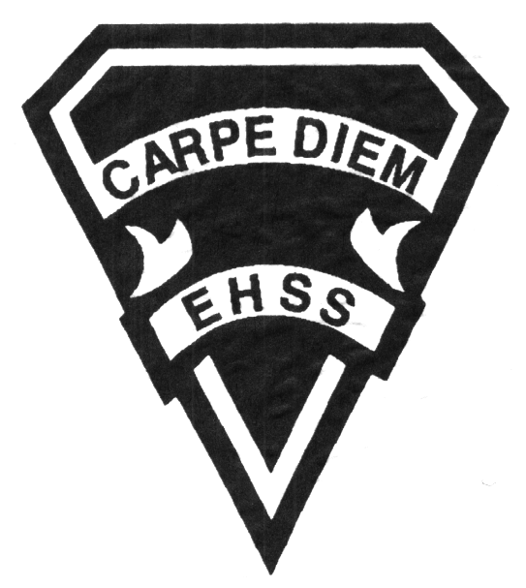

**2019/2020**

### Canada and World Politics

**Social Sciences Department**

## Earl Haig

SecondarySchool

# **CPW4U**

**Evaluation Profile & Outline**

**Course Description/Rationale/Overview:** Politics is about systems of power, public decision making and ways in which citizens can take public action. Also to become informed citizens in a democratic society, capable of participating fully in decision making, exercising their democratic rights and assuming the responsibilities of citizenship. Students need to understand how political decisions are made.

**Class Requirements:** Students should have materials specified by the subject teacher at the beginning of the year.

The textbook for this course is Canada and World Politics. Students will be issued this book at the beginning of the course. The replacement cost for this textbook $120.00.

**Assessment and Evaluation Strategies**

Students will also be expected to complete assessment activities of a formative nature in order to learn and to practice the specific expectations that will compose the summative evaluations. Examples of formative assessment may include homework checks, quizzes, peer assessment, presentations, reflection writing, role-play scenarios and observation.

Each unit or strand of the course will be evaluated using summative evaluations. Examples of summative evaluations are tests, case studies, interviews, reports, presentations, seminars, debates, research and other writing assignments.

**Late and/or Missed Evaluation**

##### Late Assignments*

For each assignment, the teacher will inform students of the due date. The teacher may decide to create an ultimate deadline. If an assignment is submitted after the deadline, the teacher may deduct marks up to and including the full value of the assignment.

**Missed Tests**

It is the student’s responsibility to make arrangements, ahead of time, for any tests/quizzes that are missed. If a student misses a test/quiz for an unforeseen reason such as illness, the student must bring a note signed by a parent or guardian**. Alternatively a medical certificate may be requested by the teacher.** The student must be prepared to write the test/quiz immediately upon return to school at a time determined by the teacher. Once the tests/quizzes have been evaluated and returned, students will not be able to make up a missed test - a mark of zero will be assigned.

**Subject-Specific/Department Information**

Teachers in the Social Sciences Department can be reached at (416) 395-3210, ext. 20075 or 20085. Parents wishing to meet with a teacher are requested to make an appointment with the teacher prior to coming to the school.

**Learning Skills\***

**Responsibility** – meets deadlines; takes responsibility for own behaviour

**Organization** – establishes priorities and manages time; uses information, technology and resources top complete tasks time management

**Independent Work** – follows instruction with minimal supervision; uses class time appropriately to complete tasks

**Collaboration** – accepts an equitable share of work in a group; builds healthy peer relationships; works with others to achieve group goals

**Initiative** – looks for opportunities for learning; demonstrates curiosity; approaches new tasks with a positive attitude

**Self-regulation** – sets own goals and monitors own progress; seeks assistance with needed; makes an effort with responding to challenges

###### Final Mark

The final mark for this course will be determined based upon an accumulation of marks from unit summative activities and from a final summative evaluation

**Year’s Work 70%**

This is a culmination of evaluations that have been completed throughout the year. It may include tests, presentations, research, or topic specific assignments.

**Final Summative Evaluation 30%**

The summative activity for this course will be comprised of an assignment (15%) and a comprehensive final exam based on concepts and themes presented in the course (15%).

**Achievement Categories and Weighting**

* **Knowledge / Understanding – 20%**

Knowledge of facts and terms; understanding of concepts, principles, guidelines and strategies; understanding of relationships among concepts.

* **Application – 30%**

Synthesizing knowledge and understanding into new and familiar contexts as well as making connections between various contexts.

* **Thinking – 40%**

Formulating questions; planning, selecting strategies and resources; analyzing and interpreting information, and forming conclusions.

* **Communication – 10%**

Communication of information and ideas, communication for different audiences, use of various forms of communication.

*From: Ontario Ministry of Education. *Growing Success: Assessment, Evaluation, and Reporting in Ontario Schools*. Toronto: Ministry of Education, 2010, 11.



**2019/2020**

##### Canada and World Politics

**Social Sciences Department**

## Earl Haig

SecondarySchool

# **CPW4U**

**Evaluation Profile & Outline**

**Course Outline:**

**Unit 1: Citizenship, Democracy and Participation**

The participation of citizens in a democratic society is both a right and a responsibility. At various times and for various reasons, the nature of such participation has been shaped and limited by differences in region, race, ethnicity, religion, language, culture, gender, age and class. In a democracy, well-informed citizens should understand such principles as equality under the law, majority rule and minority representation. Students need to understand that widespread, informed and effective citizen participation is the hallmark of democracy, as well as an important part of the development of the social well being of individual citizens.

Unit 2: Participation in the International Community

Citizens, groups and states all participate in the international community, have rights and responsibilities associated with this participation and both cooperate and conflict with one another. Among the organizations that interact internationally are transnational corporations, non-governmental organizations such as Amnesty International and international cooperation organizations such as World Health Organization. Canada’s international involvement, both historical and present includes a number of commitments, agreements and conflicts. Students should understand the impact of such commitments and agreements, as well as ways in which international conflicts are resolved. Finally, students should be familiar with the international human rights protection system, including founding documents and the agencies that enforce them.

Unit 3: Power, Influence and the Resolution of Differences

An understanding of the diverse nature and exercise of power and influence is central to the study of politics. Power and influence are forms of authority and are essential to the everyday workings of the political life of groups, cities and nations. They are characterized by a variety of styles and methods ranging from open democratic debate to closed authoritarian repression through the use of processes such as free elections, consensual decision making and forced assumptions. The exercise of power and influence can range from reaching peaceful agreements to waging war.

Unit 4: Decision-making Systems and Processes

People create political systems and processes to deal in a predictable way with persistent political issues. At the same time, people’s opinions and actions are often influenced by the systems and processes the have created. Students need to identify the roles that individuals play within political systems in a global context. Evaluate the extent to which these systems and processes are democratic and effective. Compare the involvement of citizens in decision-making processes in Cuba, the U.S. and around the world. Students should also understand the role of regulatory and judicial processes in our democratic society.

Unit 5: Values, Beliefs and Ideologies

Values, beliefs and ideologies are the key elements in individual and group identities. They are important motivators of political behaviour and important by-products of political, economic and social change. Students should recognize how their values, beliefs and ideas shape the political decisions and choices that they make.